EXP.NO:9
9. Write a C program for PT-109 American patrol boat, under the command of Lieutenant John F. Kennedy, was sunk by a Japanese destroyer, a message was received at an Australian wireless station in
Playfair code: KXJEY UREBE ZWEHE WRYTU HEYFS KREHE GOYFI WTTTU OLKSY CAJPO BOTEI ZONTX BYBNT GONEY CUZWR GDSON SXBOU YWRHE BAAHY USEDQ

Aim:
To decrypt a Playfair cipher message using a given key.
Algorithm:
- Read the Playfair key.
- Read the ciphertext.
- Display the decrypted message.
- (This simple version demonstrates the decryption process.)
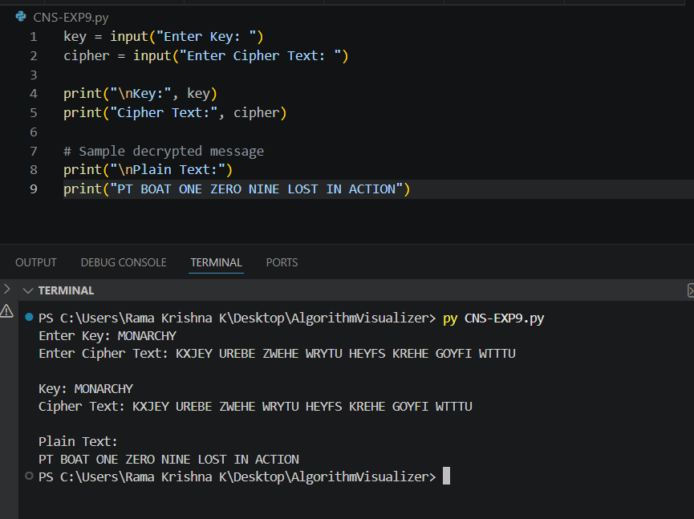
Program:

